HTML

🌐 What is HTML?
# Source: AI Source: Provided by: [Data Path: Persons Table -> ID Column: 1, Name_En Column: Motasem Essam] -> From: [Chatgpt (GPT‑5 Mini)] on [1/26/2026]
HTML stands for HyperText Markup Language.
It is the standard language used to create and structure content on the web — such as text, links, images, tables, forms, and more.

🧱 HTML = Structure of a Web Page
# Source: AI Source: Provided by: [Data Path: Persons Table -> ID Column: 1, Name_En Column: Motasem Essam] -> From: [Chatgpt (GPT‑5 Mini)] on [1/26/2026]
Think of HTML as the skeleton of a webpage.
It tells the browser what to show and how it's organized, but not how it looks (that’s CSS) or behaves (that’s JavaScript).

📄 Simple HTML Example
# Source: AI Source: Provided by: [Data Path: Persons Table -> ID Column: 1, Name_En Column: Motasem Essam] -> From: [Chatgpt (GPT‑5 Mini)] on [1/26/2026]
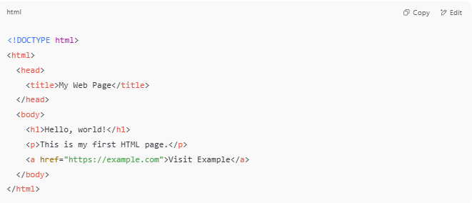
<!DOCTYPE html>
<html>
<head>
<title>My Web Page</title>
</head>
<body>
<h1>Hello, world!</h1>
<p>This is my first HTML page.</p>
<a href="https://example.com">Visit Example</a>
</body>
</html>

🔹 Key HTML Concepts
# Source: AI Source: Provided by: [Data Path: Persons Table -> ID Column: 1, Name_En Column: Motasem Essam] -> From: [Chatgpt (GPT‑5 Mini)] on [1/26/2026]
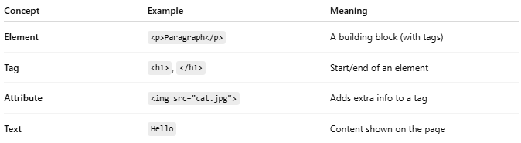

Concept | Example | Meaning
Element | <p>Paragraph</p> | A building block (with tags)
Tag | <h1>, </h1> | Start/end of an element
Attribute | <img src="cat.jpg"> | Adds extra info to a tag
Text | Hello | Content shown on the page

🧩 Common HTML Elements
# Source: AI Source: Provided by: [Data Path: Persons Table -> ID Column: 1, Name_En Column: Motasem Essam] -> From: [Chatgpt (GPT‑5 Mini)] on [1/26/2026]
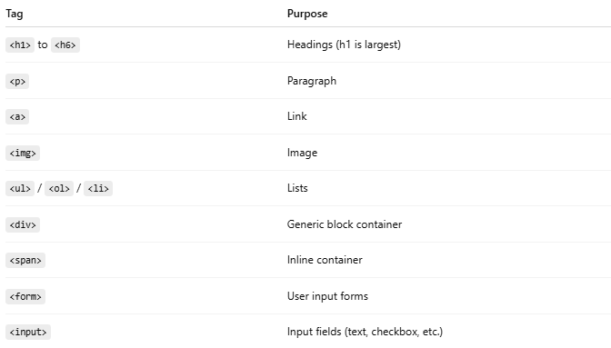
Tag | Purpose
<h1> to <h6> | Headings (h1 is largest)
<p> | Paragraph
<a> | Link
<img> | Image
<ul> / <ol> / <li> | Lists
<div> | Generic block container
<span> | Inline container
<form> | User input forms
<input> | Input fields (text, checkbox, etc.)

📐 HTML Page Structure
# Source: AI Source: Provided by: [Data Path: Persons Table -> ID Column: 1, Name_En Column: Motasem Essam] -> From: [Chatgpt (GPT‑5 Mini)] on [1/26/2026]
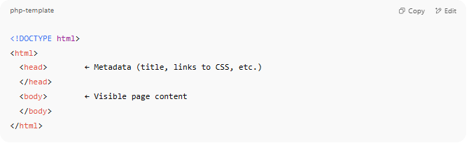
<!DOCTYPE html>
<html>
<head> ← Metadata (title, links to CSS, etc.)
</head>
<body> ← Visible page content
</body>
</html>

🖥️ HTML in Action (Browser View)
# Source: AI Source: Provided by: [Data Path: Persons Table -> ID Column: 1, Name_En Column: Motasem Essam] -> From: [Chatgpt (GPT‑5 Mini)] on [1/26/2026]
The browser takes this HTML:
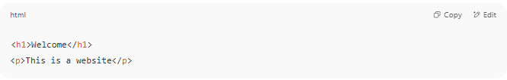
<h1>Welcome</h1>
<p>This is a website</p>

And displays:

Welcome
This is a website

🧠 Summary
# Source: AI Source: Provided by: [Data Path: Persons Table -> ID Column: 1, Name_En Column: Motasem Essam] -> From: [Chatgpt (GPT‑5 Mini)] on [1/26/2026]
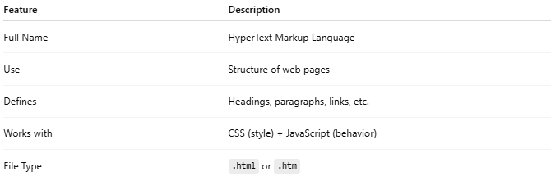

Feature | Description
Full Name | HyperText Markup Language
Use | Structure of web pages
Defines | Headings, paragraphs, links, etc.
Works with | CSS (style) + JavaScript (behavior)
File Type | .html or .htm

